Year 6 Home Learning 02.10.25
  October is Black History Month  This year’s theme is ‘Standing Firm in Power and Pride’  This week, your home learning is to celebrate black voices and achievements!  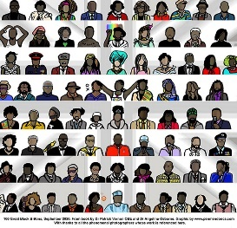  Can you choose one influential Black Briton and create a presentation or poster about them.  Consider the following:  - Who they are  - What they are known for  - Why they are inspirational  - A quote or interesting fact | Spellings  Practice the following:  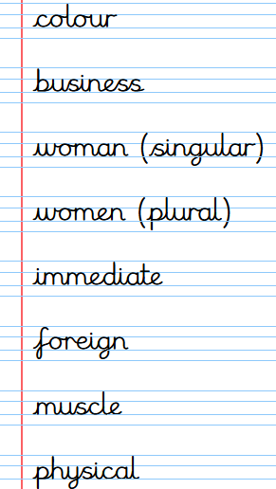
Maths
My Maths – Addition and Subtraction Word Problems

Times Tables Rockstars
Practise your times tables on Times Tables Rockstars!

Remember to read for at least 20mins every day!

