Year 6 Home Learning 06/11/25
Geography | Maths
In Geography, we have been looking at the geography of Egypt (and Ancient Egypt).  For home learning this week,  Use an atlas or online map to:  - Locate the River Nile.  - Identify the countries it flows through.  - Mark the source and mouth of the river.  - Find key cities along the Nile (e.g., Cairo, Khartoum).  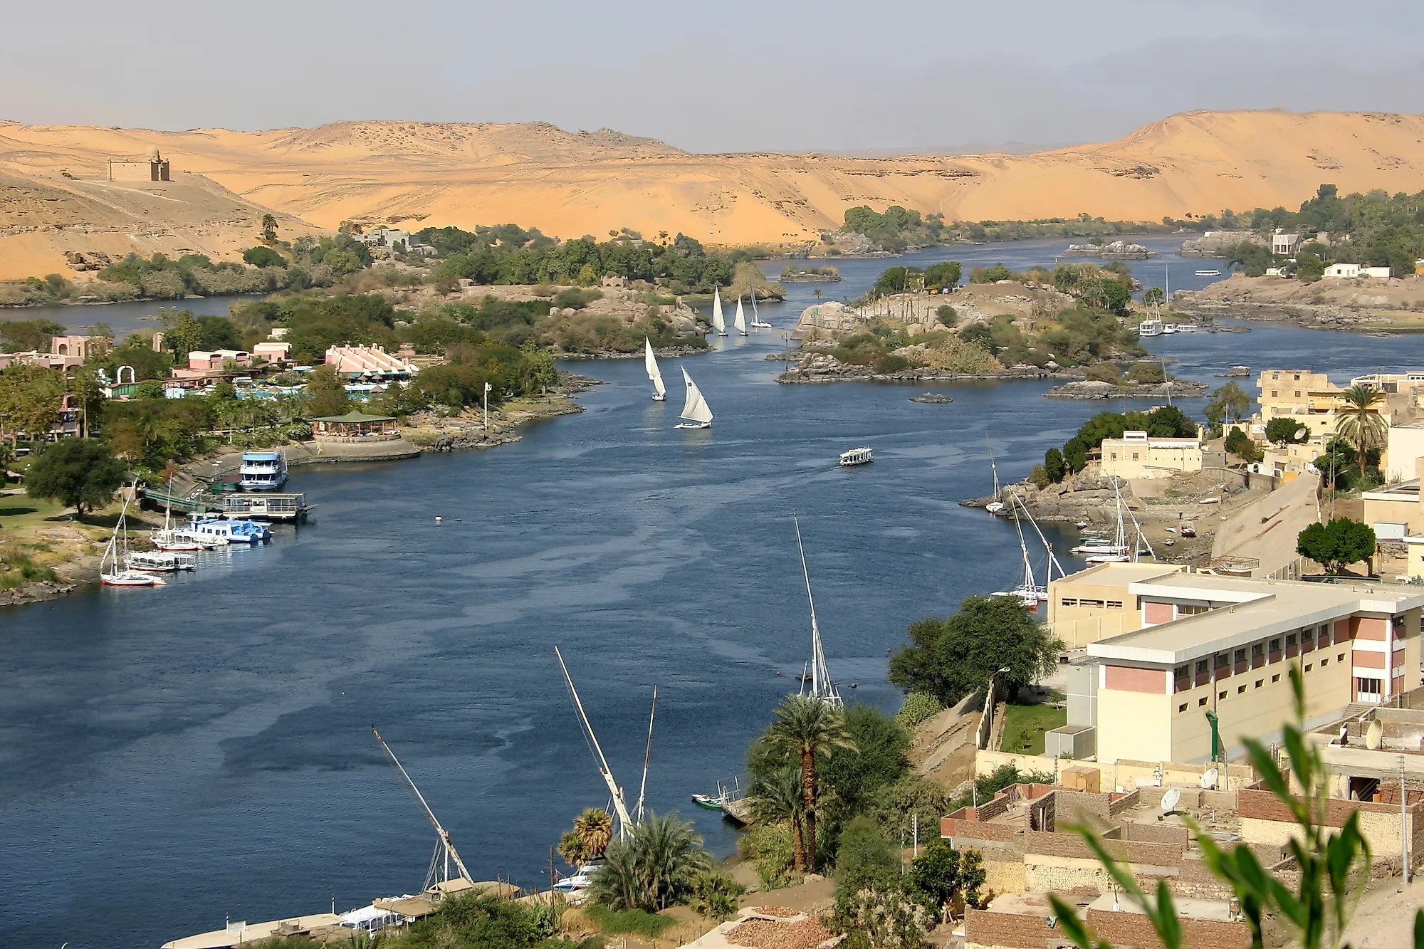  You could even draw your own map of the Nile and label it with geographical features like delta, tributaries, and floodplains! | Maths.co.uk  Log into maths.co.uk and see which challenges you have been set    Times Tables Rockstars  Practise your times tables on Times Tables Rockstars!  
Spellings
Can you learn these spellings and their root words for our quiz next week:
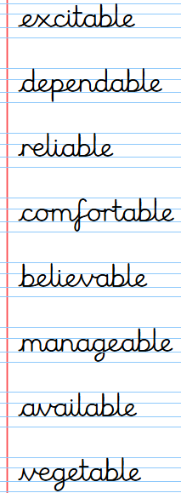
Practise by writing a sentence for each word.

Remember to read for at least 20 minutes every day!

