Year 5 Home Learning– 6th November 2025
In maths we have been learning about multiples and factors.  Can you find the answer? Then, can you make a similar problem for your classmates and teachers to work out?  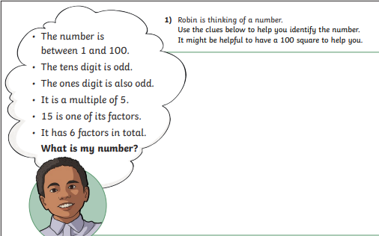 | Spellings – ‘ie’ / ‘ei’
  science | species | ancient | society
  weird | height | foreign | neighbour

Log in to your MyMaths account and try some of the activities that your teacher has set for you!


Log in to your TTRS account and practise your times tables.
Remember to read for at least 20 minutes every day!

Year 5 Home Learning– 6th November 2025
In maths we have been learning about multiples and factors.  Can you find the answer? Then, can you make a similar problem for your classmates and teachers to work out? | Spellings – ‘ie’ / ‘ei’
  science | species | ancient | society
  weird | height | foreign | neighbour
Log in to your MyMaths account and try some of the activities that your teacher has set for you!

Log in to your TTRS account and practise your times tables.
Remember to read for at least 20 minutes every day!

