Year 5 Home Learning– 12th November 2025
In English we have been creating reports about sea creatures.  At home, make a report about a creature which interests you. You could even create an imaginary creature and write about it!  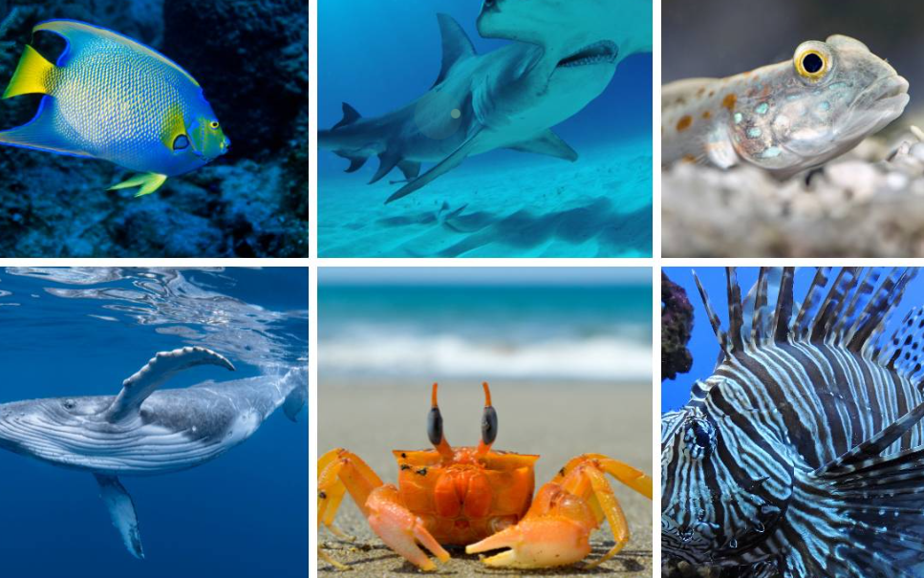 | Spellings – Words that end with the ‘el’ sound  middle, little, travel, tunnel, label, pencil, metal, capital, animal

Log in to your MyMaths account and try some of the activities that your teacher has set for you!


Log in to your TTRS account and practise your times tables.
Remember to read for at least 20 minutes every day!

