Year 6 Home Learning 13.11.25
Year 6 Winter Variety Show | Maths
Soon, we will begin rehearsing for our ‘Winter Variety Show’.  In preparation for this, you need to learn the songs in your song book.  Links for the songs are on the blog to help you practice.  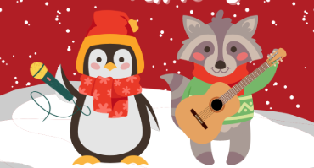 | Maths  Check Maths.co.uk for  this week’s activity.    Times Tables Rockstars  Practise your times tables on Times Tables Rockstars!  
Spellings
Can you learn these spellings and their root words for our quiz next week:
actual | believe
marvellous | curiosity
strange | controversy
material | apparent
Practise by writing a sentence for each word.
Remember to read for at least 20 minutes every day!

Year 6 Home Learning 13.11.25
Year 6 Winter Variety Show | Maths
Soon, we will begin rehearsing for our ‘Winter Variety Show’.  In preparation for this, you need to learn the songs in your song book.  Links for the songs are on the blog to help you practice. | Maths  Check Maths.co.uk for  this week’s activity.  Times Tables Rockstars  Practise your times tables on Times Tables Rockstars!
Spellings
Can you learn these spellings and their root words for our quiz next week:
actual | believe
marvellous | curiosity
strange | controversy
material | apparent
Practise by writing a sentence for each word.
Remember to read for at least 20 minutes every day!

Year 6 Home Learning 13.11.25
Year 6 Winter Variety Show | Maths
Soon, we will begin rehearsing for our ‘Winter Variety Show’.  In preparation for this, you need to learn the songs in your song book.  Links for the songs are on the blog to help you practice. | Maths  Check Maths.co.uk for  this week’s activity.  Times Tables Rockstars  Practise your times tables on Times Tables Rockstars!
Spellings
Can you learn these spellings and their root words for our quiz next week:
actual | believe
marvellous | curiosity
strange | controversy
material | apparent
Practise by writing a sentence for each word.
Remember to read for at least 20 minutes every day!

