Year 6 Home Learning 20.11.25
Writing - Film Critics | Maths
This week, we went on a trip to the cinema to watch the fantastic film Missing Link!    For this week’s home learning, write a review of the film. You might include some of the following:  - What the film is about (a short summary of the story).  - Your favourite character and why you liked them.  - Your favourite scene and what made it special.  - What you thought of the animation and music.  - How the film made you feel.  - Would you recommend it to others? Why or why not?  - Give the film a rating out of 5 stars. | Maths  Check Maths.co.uk for  this week’s activity.    Times Tables Rockstars  Practise your times tables on Times Tables Rockstars!  
Spellings
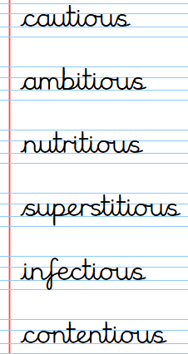
Can you learn these spellings and their root words for our quiz next week:
Remember to read for at least 20 minutes every day!
Year 6 Home Learning 20.11.25
Writing - Film Critics | Maths
This week, we went on a trip to the cinema to watch the fantastic film Missing Link!  For this week’s home learning, write a review of the film. You might include some of the following:  - What the film is about (a short summary of the story).  - Your favourite character and why you liked them.  - Your favourite scene and what made it special.  - What you thought of the animation and music.  - How the film made you feel.  - Would you recommend it to others? Why or why not?  - Give the film a rating out of 5 stars. | Maths  Check Maths.co.uk for  this week’s activity.  Times Tables Rockstars  Practise your times tables on Times Tables Rockstars!
Spellings
Can you learn these spellings and their root words for our quiz next week:
Remember to read for at least 20 minutes every day!

