Year 6 Home Learning 04.12.25
History – Ancient Egyptians | Maths
The Ancient Egyptians had a whole world of fascinating gods and goddesses, each with their own powers, stories and symbols.  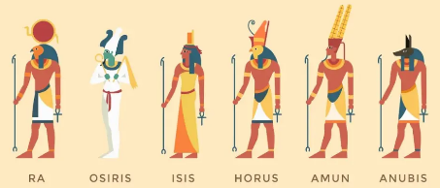  For home learning this week, pick one Egyptian god or goddess that interests you most. Research who they were, what they looked like and what they were known for. Create a colourful, eye-catching poster to teach others about them!  Your poster could include:  - A drawing or picture of the god/goddess  - Their name (in English and, if you’re feeling adventurous, in hieroglyphs!)  - What they were the god/goddess of (e.g. Ra – the Sun God)  - Any special symbols or animals linked to them  - A fun fact that will surprise your reader | Maths  Check Maths.co.uk for  this week’s activity.    Times Tables Rockstars  Practise your times tables on Times Tables Rockstars!  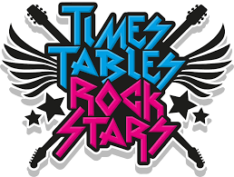
Spellings
Can you learn these spellings for our quiz next week:
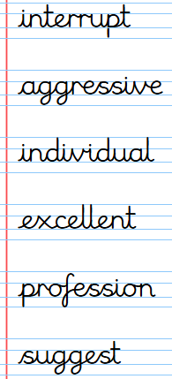
Remember to read for at least 20 minutes every day!

Year 6 Home Learning 04.12.25
History – Ancient Egyptians | Maths
The Ancient Egyptians had a whole world of fascinating gods and goddesses, each with their own powers, stories and symbols.  For home learning this week, pick one Egyptian god or goddess that interests you most. Research who they were, what they looked like and what they were known for. Create a colourful, eye-catching poster to teach others about them!  Your poster could include:  - A drawing or picture of the god/goddess  - Their name (in English and, if you’re feeling adventurous, in hieroglyphs!)  - What they were the god/goddess of (e.g. Ra – the Sun God)  - Any special symbols or animals linked to them  - A fun fact that will surprise your reader | Maths  Check Maths.co.uk for  this week’s activity.  Times Tables Rockstars  Practise your times tables on Times Tables Rockstars!
Spellings
Can you learn these spellings for our quiz next week:
Remember to read for at least 20 minutes every day!

