Year 5 Home Learning - 7th January 2026
Science – Planets  In Science, we are learning about the planets!  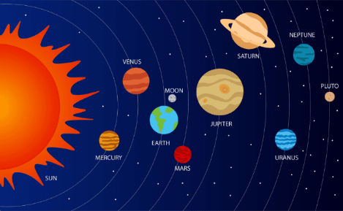  We would like you to choose one planet to research about and create a fact file. You could produce a poster, a book, a PowerPoint presentation, a 3D model, a video – be creative!  Here are some questions to get you started:  - How big is the planet?  - How many moons does it have?  - What is the temperature on the planet?  - How far away from the sun is the planet?  - What is its appearance?  You will be sharing our facts with your classmates in your Science lesson next week so please make sure you bring them in! | Spellings- Suffixes  Silent ‘k’- knock, knocked, know, knew, knowledge, knee, knight, night
MyMaths

Please login and use Times Table Rockstars- lets get Year 5 to the top!

Remember to read for at least 20 minutes every day!

