Year 6 Home Learning 08.01.26
Geography | Maths
In Geography this term we will be learning all about different climates, biomes and landscapes. For home learning this week, we will recap on the invisible lines that surround the Earth.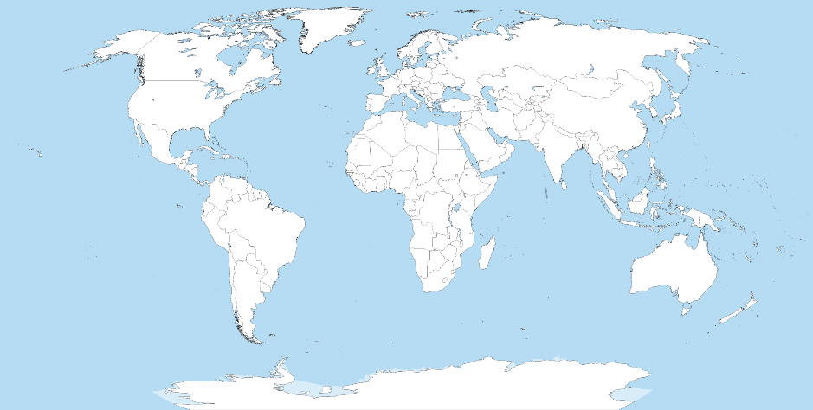  Can you label the following lines of latitude on the map above:  - the Equator  - Tropic of Cancer  - Tropic of Capricorn  - the Arctic Circle  - the Antarctic Circle  Challenge!  Can you label the Prime Meridian line of longitude? | Check Maths.co.uk for  this week’s activity.    Times Tables Rockstars  Practise your times tables on Times Tables Rockstars!  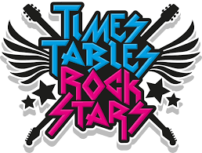
 | Spelling
Words ending with -ation

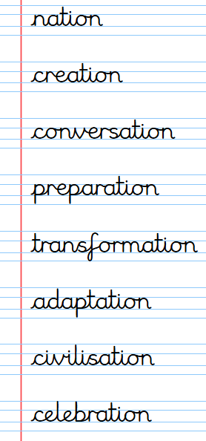

Practise these spellings ready for our quiz next Friday!
Remember to read for at least 20mins every day. Have a brilliant weekend!

Year 6 Home Learning 08.01.26
Geography | Maths
In Geography this term we will be learning all about different climates, biomes and landscapes. For home learning this week, we will recap on the invisible lines that surround the Earth.  Can you label the following lines of latitude on the map above:  - the Equator  - Tropic of Cancer  - Tropic of Capricorn  - the Arctic Circle  - the Antarctic Circle  Challenge!  Can you label the Prime Meridian line of longitude? | Check Maths.co.uk for  this week’s activity.  Times Tables Rockstars  Practise your times tables on Times Tables Rockstars!
 | Spelling
Words ending with -ation

Practise these spellings ready for our quiz next Friday!
Remember to read for at least 20mins every day. Have a brilliant weekend!

