Year 6 Home Learning 05/12/26
Geography | Maths
Climate Change  As we have been learning, Earth has different climate zones, which are areas with similar weather patterns over a long period of time. Although climate zones stay mostly the same for thousands of years, humans can change the climate much more quickly. The main way humans are changing the climate is by producing greenhouse gases, especially carbon dioxide (CO₂).  Your job is to explore the different ways people can make environmentally friendly choices in their everyday lives. You might explore:    - Reducing waste  - Saving energy  - Sustainable travel  - Eco‑friendly food choices  - Protecting nature  - Saving water  Record your findings and present them creatively (poster, mindmap, presentation, short report etc.) | Check Maths.co.uk for  this week’s activity.    Times Tables Rockstars  Practise your times tables on Times Tables Rockstars!  
 | Spelling
Words with
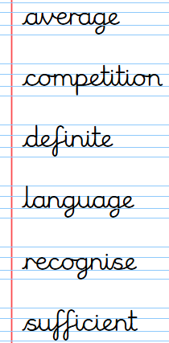

Practise these spellings ready for our quiz next Friday!
Remember to read for at least 20mins every day. Have a brilliant weekend!

Year 6 Home Learning 05/12/26
Geography | Maths
Climate Change  As we have been learning, Earth has different climate zones, which are areas with similar weather patterns over a long period of time. Although climate zones stay mostly the same for thousands of years, humans can change the climate much more quickly. The main way humans are changing the climate is by producing greenhouse gases, especially carbon dioxide (CO₂).  Your job is to explore the different ways people can make environmentally friendly choices in their everyday lives. You might explore:  - Reducing waste  - Saving energy  - Sustainable travel  - Eco‑friendly food choices  - Protecting nature  - Saving water  Record your findings and present them creatively (poster, mindmap, presentation, short report etc.) | Check Maths.co.uk for  this week’s activity.  Times Tables Rockstars  Practise your times tables on Times Tables Rockstars!
 | Spelling
Words with

Practise these spellings ready for our quiz next Friday!
Remember to read for at least 20mins every day. Have a brilliant weekend!

