Year 5 Home Learning– 5th February 2026
History  In History, we have been learning about the Ancient Greeks.  We have found out that vases were very important to the Ancient Greeks and showed scenes from mythology, daily life, athletics and war.  We want you to look at these vases and write down what you can find out about the Ancient Greeks and their lives.  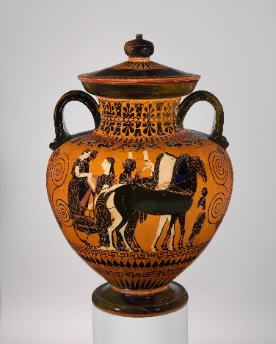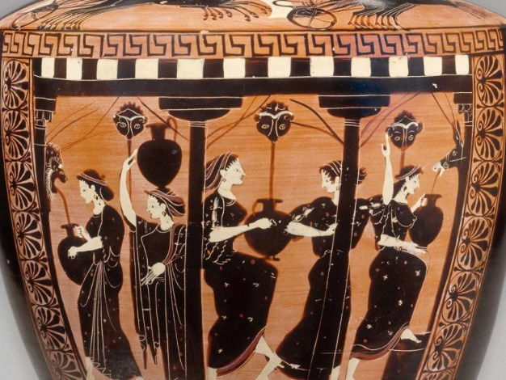  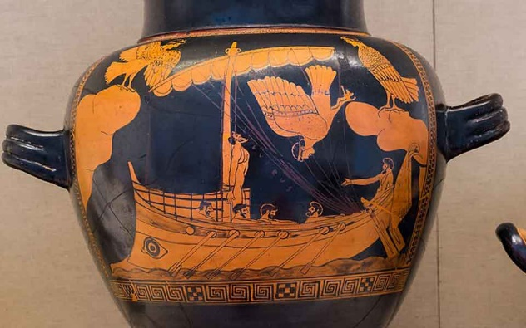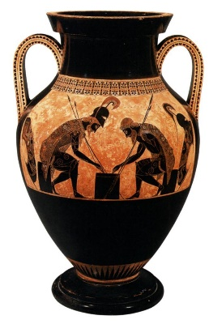  Challenge: Can you draw your own vase showing an aspect of Ancient Greek life? | Spellings – ‘w’ and ‘wh’  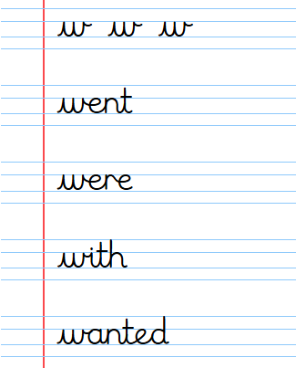  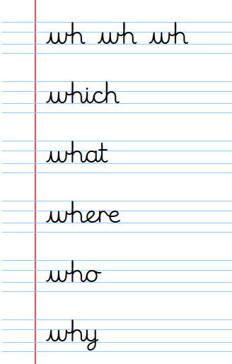

Log in to your TTRS account and practise your times tables.

It will really help you with the division that we’re doing in Maths lesson this week!
Remember to read for at least 20 minutes every day!

