Year 6 Home Learning 13.02.26
Science
Choose a minimum 3 of these exciting activities to complete.
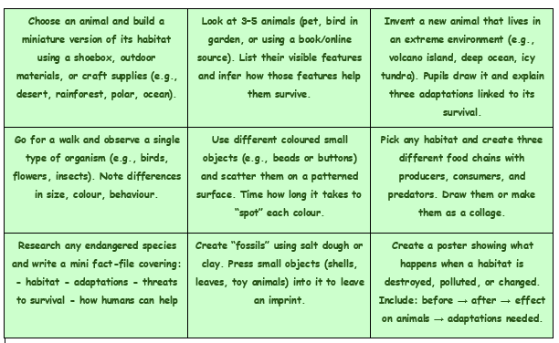
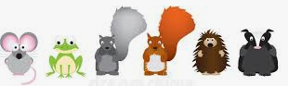
Maths  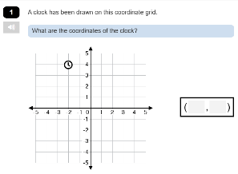  Log in to Maths.co.uk to complete what this week’s coordinates activity. | Spellings  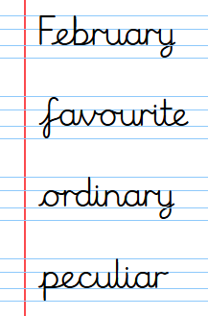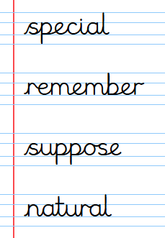
Remember to read for at least 20mins every day. Have a brilliant half term holiday!

