Year 6 Home Learning 05.03.26
Holbeach Science Week! | Maths
Next week is Science Week at Holbeach!  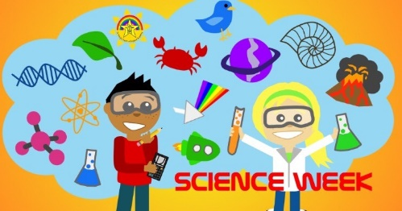  For home learning, undertake the following investigation:  Inheritance is when living things pass characteristics (traits) to their offspring. You inherit traits from your biological parents. You get a mix of characteristics from both. Offspring are similar to their parents — but not identical. Differences are called variation.  You can include any biological family members you feel comfortable discussing.  Investigate some physical traits (e.g. eye colour, dimples, hair colour, freckles, earlobes (attached/free) and create a table to share your findings.  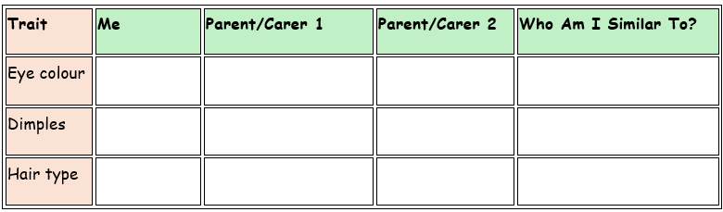 | Check Maths.co.uk for  this week’s activity.    Times Tables Rockstars  Practise your times tables on Times Tables Rockstars!  
 | Spelling
Words with ‘i’ before ‘e’ except after ‘c’
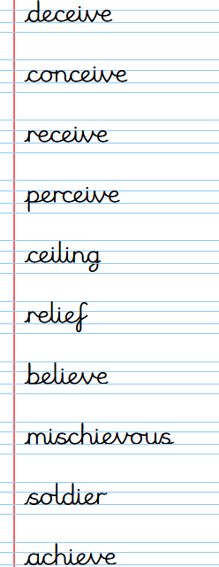
Practise these spellings ready for our quiz next Friday!
Remember to read for at least 20mins every day. Have a brilliant weekend!

