Year 5 Home Learning– 5th March 2026
Science  It is British Science week!  We have been creating brilliant biographies about Katherine Johnson – a famous computer scientist.  We would like you to research about another famous scientist.  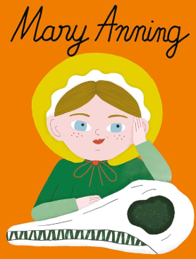  You can find out…  What are they most famous for?  What inspired them?  What challenges did they face?  How did their work change the world? | Spellings  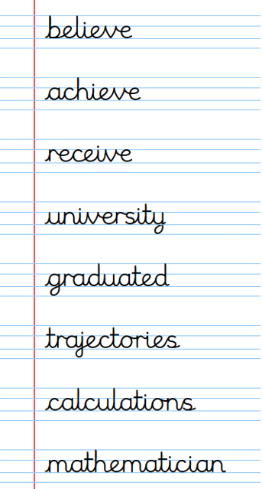

Log in to your My Maths account and try some of the activities that your teacher has set for you!

Log in to your TTRS account and practise your times tables.
Remember to read for at least 20 minutes every day!

Year 5 Home Learning– 5th March 2026
Science  It is British Science week!  We have been creating brilliant biographies about Katherine Johnson – a famous computer scientist.  We would like you to research about another famous scientist.  You can find out…  What are they most famous for?  What inspired them?  What challenges did they face?  How did their work change the world? | Spellings
Log in to your My Maths account and try some of the activities that your teacher has set for you!
Log in to your TTRS account and practise your times tables.
Remember to read for at least 20 minutes every day!

