Year 6 Home Learning 12.03.26
Geography | Maths
This term, we will be learning more about lines of longitude and time zones.  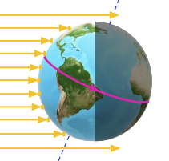  Earth is a giant sphere, like this globe. Earth is constantly rotating on its axis, making one full rotation every 24 hours. We call each complete rotation a day. This rotation gives us night and day. At any moment, half of Earth faces the sun and experiences the light and heat from the sun’s rays while the other half is in darkness.  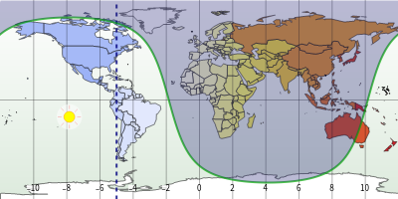  For home learning, can you list 5 examples of places where it is day and night, for example:  day = Rio de Janeiro  night = Rome  Challenge! – Can you research how lines of longitude are linked to time zones? | Check Maths.co.uk for  this week’s activity.    Times Tables Rockstars  Practise your times tables on Times Tables Rockstars!  
 | Spelling
Y5/6 Spellings
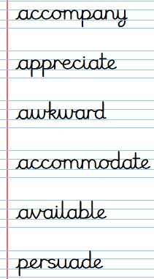
Practise these spellings ready for our quiz next Friday!
Remember to read for at least 20mins every day. Have a brilliant weekend!
Year 6 Home Learning 12.03.26
Geography | Maths
This term, we will be learning more about lines of longitude and time zones.  Earth is a giant sphere, like this globe. Earth is constantly rotating on its axis, making one full rotation every 24 hours. We call each complete rotation a day. This rotation gives us night and day. At any moment, half of Earth faces the sun and experiences the light and heat from the sun’s rays while the other half is in darkness.  For home learning, can you list 5 examples of places where it is day and night, for example:  day = Rio de Janeiro  night = Rome  Challenge! – Can you research how lines of longitude are linked to time zones? | Check Maths.co.uk for  this week’s activity.  Times Tables Rockstars  Practise your times tables on Times Tables Rockstars!
 | Spelling
Y5/6 Spellings
Practise these spellings ready for our quiz next Friday!
Remember to read for at least 20mins every day. Have a brilliant weekend!

