Year 6 Home Learning 19.03.26
  Shakespeare Week  Next week is national Shakespeare Week.  We would like you to visit this website:  https://www.bbc.co.uk/teach/class-clips-video/articles/zjyhrj6  Some of Shakespeare’s plays have been modernised and set to music. Enjoy watching at least three videos before choosing your favourite story.  Use your favourite story to create a graphic novel.  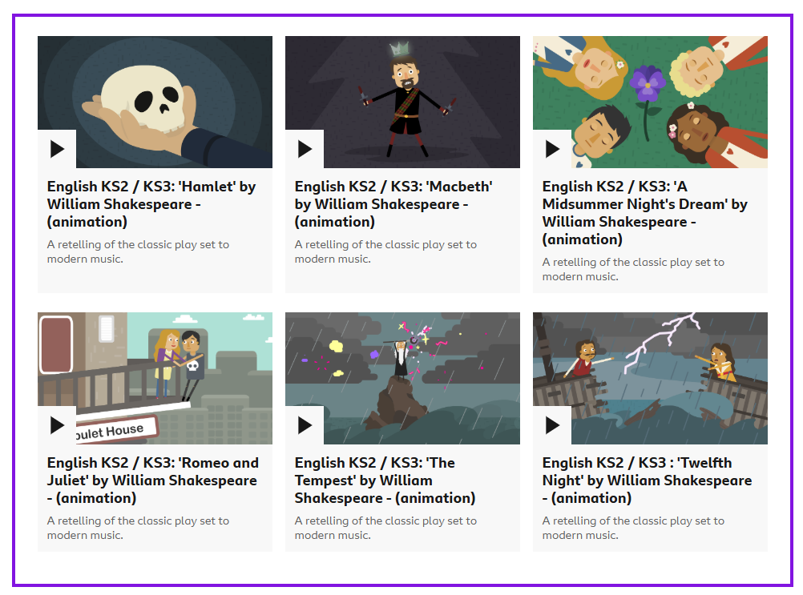 | Maths
Check Maths.co.uk for
this week’s activity.


Times Tables Rockstars
Practise your times tables on Times Tables Rockstars!


 | Spelling
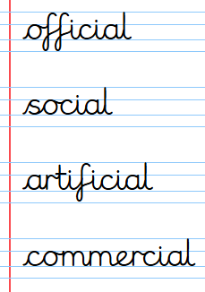
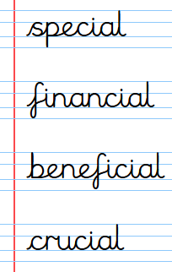
Practise these spellings ready for our quiz next Friday!
Remember to read for at least 20mins every day. Have a brilliant weekend!

Year 6 Home Learning 19.03.26
  Shakespeare Week  Next week is national Shakespeare Week.  We would like you to visit this website:  https://www.bbc.co.uk/teach/class-clips-video/articles/zjyhrj6  Some of Shakespeare’s plays have been modernised and set to music. Enjoy watching at least three videos before choosing your favourite story.  Use your favourite story to create a graphic novel. | Maths
Check Maths.co.uk for
this week’s activity.

Times Tables Rockstars
Practise your times tables on Times Tables Rockstars!

 | Spelling
 | Practise these spellings ready for our quiz next Friday!
Remember to read for at least 20mins every day. Have a brilliant weekend!

