Year 5 Home Learning Easter Holidays
Compare and contrast  We have been learning about the ancient Greek Olympics. Do some research to find out some similarities and differences between the events.  You could think about: the events, the athletes, the costumes, the stadiums, the crowd, prizes...  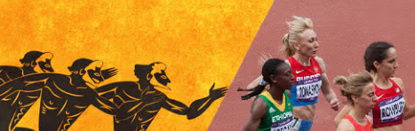 | Maths    Logon to TTRS and MyMaths and keep practising!  Explain to someone at home how to find equivalent fractions!
Spellings
These words have their roots in the Greek language- practise them at home!
system | communicate | physical | category
criticise | temperature | symbol | dictionary

Remember to read for at least 20 minutes every day!

