Year 6 Home Learning 26.03.26
In Maths, we have been learning about fractions and decimal equivalents. After half term, we will be learning all about percentages!  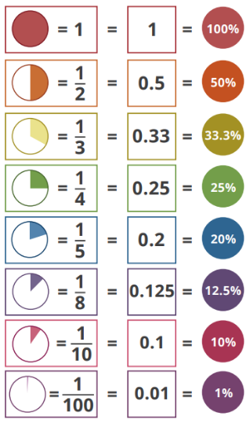  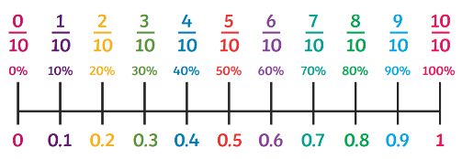  We would like you to create a poster all about the fraction, decimal and percentage equivalents to put in your Maths book as an aide memoire and to put on display in the classroom.  What patterns can you spot?  How could we remember these facts? | Maths
Check Maths.co.uk for
this week’s activity.


Times Tables Rockstars
Practise your times tables on Times Tables Rockstars!


 | Spelling
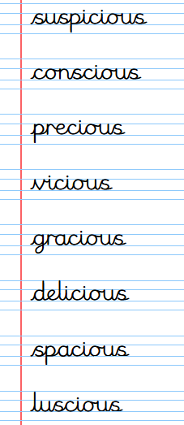
Practise these spellings ready for our quiz when we are back for the Summer Term!
Remember to read for at least 20mins every day. Have a brilliant weekend!

