Year 6 Home Learning 16.4.26
London Visitor Guide | Maths
  Can you create a visitor guide for someone who has never been to London before?  Your guide should help them understand:  Where London is and how it is organised?  What makes London a unique city to visit?  Your top 5 recommendations of landmarks/ places to visit.  You can present your work as: a mini booklet (handwritten or printed), a poster or a PowerPoint presentation. | Check Maths.co.uk for  this week’s activity.    Times Tables Rockstars  Practise your times tables on Times Tables Rockstars!  
 | Spellings
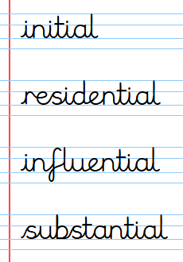
Words ending -tial
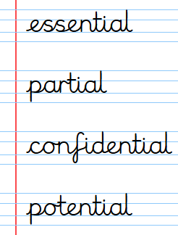
Practise these spellings ready for our quiz next Friday!
Remember to read for at least 20mins every day.
Have a brilliant weekend!

Year 6 Home Learning 16.4.26
London Visitor Guide | Maths
Can you create a visitor guide for someone who has never been to London before?  Your guide should help them understand:  Where London is and how it is organised?  What makes London a unique city to visit?  Your top 5 recommendations of landmarks/ places to visit.  You can present your work as: a mini booklet (handwritten or printed), a poster or a PowerPoint presentation. | Check Maths.co.uk for  this week’s activity.  Times Tables Rockstars  Practise your times tables on Times Tables Rockstars!
 | Spellings
Words ending -tial
Practise these spellings ready for our quiz next Friday!
Remember to read for at least 20mins every day.
Have a brilliant weekend!

