Year 6 Home Learning 23.04.26
Design & Technology | Maths
This term, our topic is ‘London – our place in the world’. In D&T, our focus is bridges. London has a total of 35 bridges.  Can you choose one of London’s bridges and create a fact file about it?  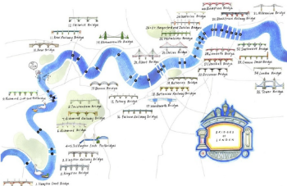  Some questions to start you thinking about the information you could include;  When was it built? Who designed it? What does it look like? What type of bridge is it? How much did it cost to build? Did it replace a previous bridge in that location? Has it featured in any films set in London?  Don’t forget to look for interesting anecdotes about the bridge! | Check Maths.co.uk for  this week’s activity.    Times Tables Rockstars  Practise your times tables on Times Tables Rockstars!  
 | Spellings
Words ending in -ant/-ance/-ancy
Practise these spellings ready for our quiz next Friday!
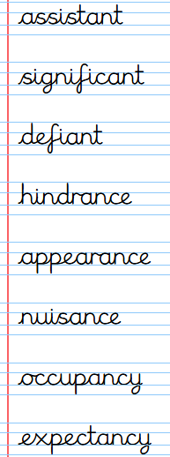
Remember to read for at least 20mins every day.
Have a brilliant weekend!

Year 6 Home Learning 23.04.26
Design & Technology | Maths
This term, our topic is ‘London – our place in the world’. In D&T, our focus is bridges. London has a total of 35 bridges.  Can you choose one of London’s bridges and create a fact file about it?  Some questions to start you thinking about the information you could include;  When was it built? Who designed it? What does it look like? What type of bridge is it? How much did it cost to build? Did it replace a previous bridge in that location? Has it featured in any films set in London?  Don’t forget to look for interesting anecdotes about the bridge! | Check Maths.co.uk for  this week’s activity.  Times Tables Rockstars  Practise your times tables on Times Tables Rockstars!
 | Spellings
Words ending in -ant/-ance/-ancy
Practise these spellings ready for our quiz next Friday!
Remember to read for at least 20mins every day.
Have a brilliant weekend!

