Year 5 Home Learning 30th April 2026
Art – Roman Still Life  In Art, we have been looking at lots of different still life paintings.  The Romans liked to show images of food in their artwork.  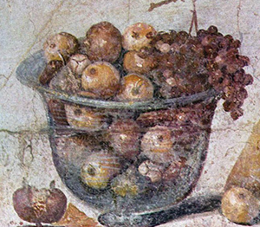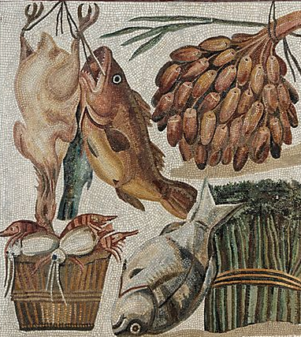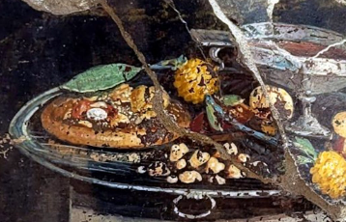  Can you find and sketch some other types of food in your home? | Spellings – words with a silent letter ‘t’  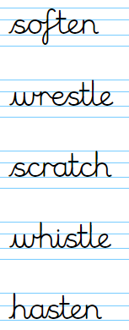  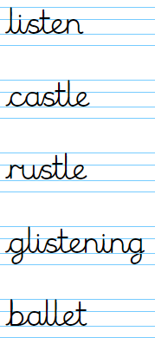
Maths



Log in to your MyMaths account and try the questions that we have set you on time.
Remember to read for at least 20 minutes every day!

