Year 6 Home Learning 30.04.26
History | Maths
May is Local History Month!  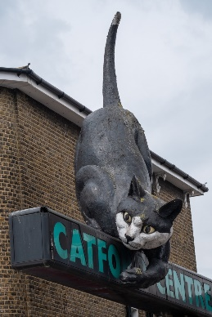  For home learning this week, you are investigating the history of Catford  Choose one of the activities below to complete.  Then and Now  Find out what Catford was like in the past and create a poster comparing Catford then and now. Include at least 3 facts and 1 picture/drawing.  You might look at:  - Old photographs  - Old maps  - Buildings that are still standing today  Landmarks  Choose one local landmark e.g. The Broadway Theatre, Catford Bridge or The Catford Cat.  Consider:  - When it was built  - Why it is important  - How it has changed over time  Present your findings as a fact file, leaflet or PowerPoint. | Check Maths.co.uk for  this week’s activity.    Times Tables Rockstars  Practise your times tables on Times Tables Rockstars!  
 | Spellings
Words ending in -ent/-ence/-ency
Practise these spellings ready for our quiz next Friday!
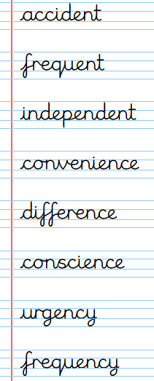
Remember to read for at least 20mins every day.
Have a brilliant weekend!

Year 6 Home Learning 30.04.26
History | Maths
May is Local History Month!  For home learning this week, you are investigating the history of Catford  Choose one of the activities below to complete.  Then and Now  Find out what Catford was like in the past and create a poster comparing Catford then and now. Include at least 3 facts and 1 picture/drawing.  You might look at:  - Old photographs  - Old maps  - Buildings that are still standing today  Landmarks  Choose one local landmark e.g. The Broadway Theatre, Catford Bridge or The Catford Cat.  Consider:  - When it was built  - Why it is important  - How it has changed over time  Present your findings as a fact file, leaflet or PowerPoint. | Check Maths.co.uk for  this week’s activity.  Times Tables Rockstars  Practise your times tables on Times Tables Rockstars!
 | Spellings
Words ending in -ent/-ence/-ency
Practise these spellings ready for our quiz next Friday!
Remember to read for at least 20mins every day.
Have a brilliant weekend!

