Year 3 Home Learning 14th May 2026
**Grown-ups ~ please supervise your child’s home learning so they are attempting the work correctly**
Tell an adult all about our Educational Visit on Wednesday. What was your favourite part of the day?  What did you learn?  Then, write a recount of the day, remembering to use time adverbials such as First of all, later on, after lunch. | 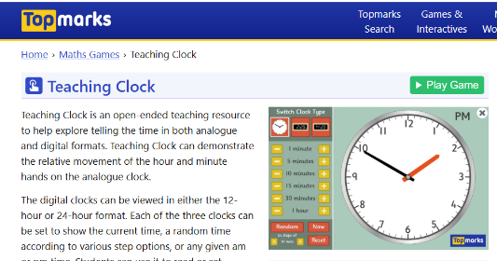  MATHS ~ time  https://www.topmarks.co.uk/time/teaching-clock  Use the interactive clock to show an adult these times:  5, 15, 25 minutes past 3, 7 and 9  10, 20, 5 minutes to 2, 6 and 12  What other times can you show?  **Don’t forget to complete tasks on MyMaths and practise times tables on TTRS**
SPELLINGS
famous favourite February forward fruit
grammar group guard guide heard
Remember to read for at least 20mins every day.

Year 3 Home Learning 14th May 2026
**Grown-ups ~ please supervise your child’s home learning so they are attempting the work correctly**
Tell an adult all about our Educational Visit on Wednesday. What was your favourite part of the day?  What did you learn?  Then, write a recount of the day, remembering to use time adverbials such as First of all, later on, after lunch. | MATHS ~ time  https://www.topmarks.co.uk/time/teaching-clock  Use the interactive clock to show an adult these times:  5, 15, 25 minutes past 3, 7 and 9  10, 20, 5 minutes to 2, 6 and 12  What other times can you show?  **Don’t forget to complete tasks on MyMaths and practise times tables on TTRS**
SPELLINGS
famous favourite February forward fruit
grammar group guard guide heard
Remember to read for at least 20mins every day.

