Year 6 Home Learning 04.06.26
Oliver With A Twist
This week we have been practising our Year 6 production, Oliver With A Twist!
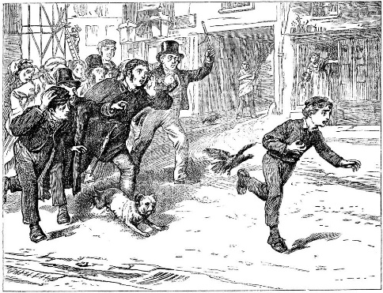
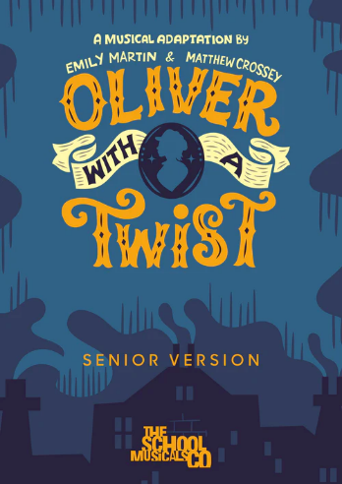


For home learning this week, please practise the songs for the production – please see the links on the website!
Remember to read for at least 20mins every day!
Year 6 Home Learning 04.06.26
Oliver With A Twist
This week we have been practising our Year 6 production, Oliver With A Twist!

For home learning this week, please practise the songs for the production – please see the links on the website!
Remember to read for at least 20mins every day!

