Year 5 Home Learning 11th June 2026
Maths – Decimals  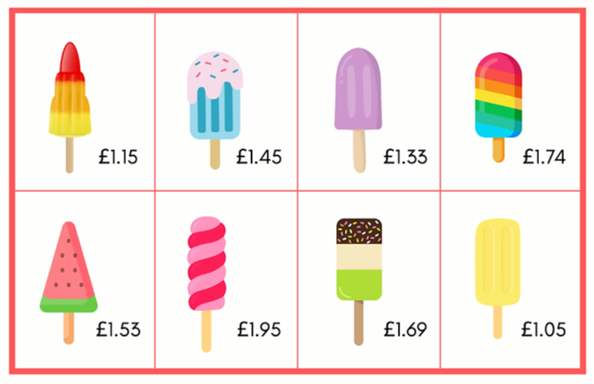  Can you work out the totals of these combinations? (Use the column method!)  Can you find the difference between the price of these lollies?  Challenge: You have £5 to spend. What combinations of lollies could you buy? How much change would you get? | Spellings – words ending with -ed  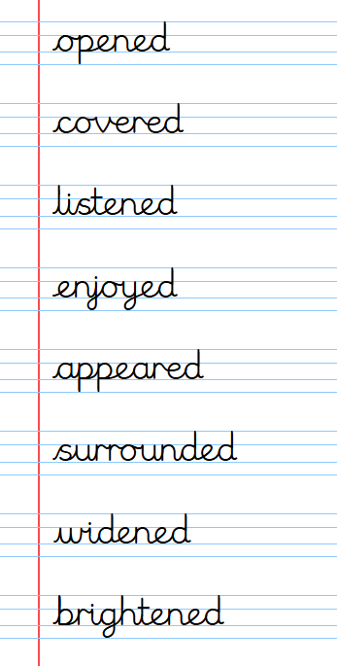  Vocabulary for Next Week  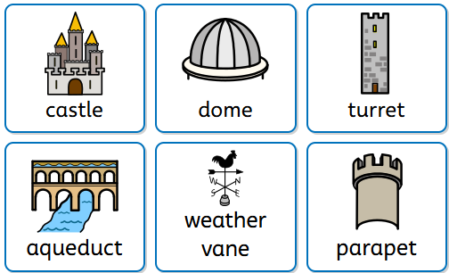
   + = | ++ +=
  + + + +  + =
   | 
   | 
Remember to read for at least 20 minutes every day!

