Year 4 Home Learning 18th June 2026
Culture week  Choose a country from around the world that means something to you. It could be the country you are from, a country you have always wanted to visit or a country that makes your favourite food!  Then make a mini poster in your book about this country looking at:  Country name  A traditional food  A celebration or festival  Clothing or special item  A word or greeting from that culture (e.g. “Hola”, “Bonjour”)  Their most popular religion  Thei capital  What you like most about this country  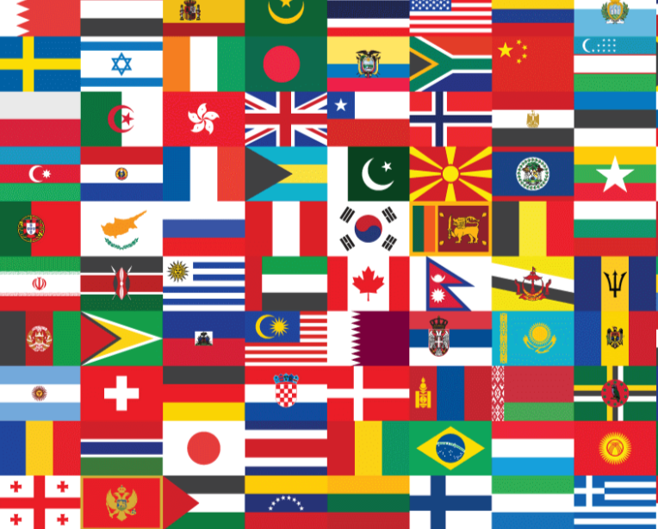 | Maths  Complete this week’s MyMaths revision task and then check your heat map on TTRS so you know what times tables to focus on.  
Spellings:
because beautiful different important special thought through enough believe breathe caught complete imagine increase ordinary particular popular regular

