Year 3 Home Learning 25th June 2026
**Grown-ups ~ please supervise your child’s home learning so they are attempting the work correctly**
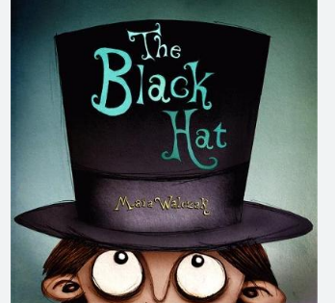  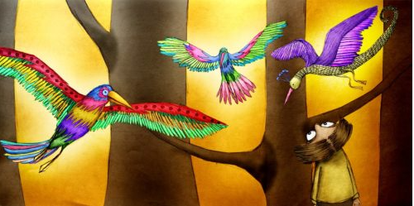  Imagine you found a black hat like the boy in the story and in the night something magical happened…  Write and draw about it. Be as descriptive as you can. | 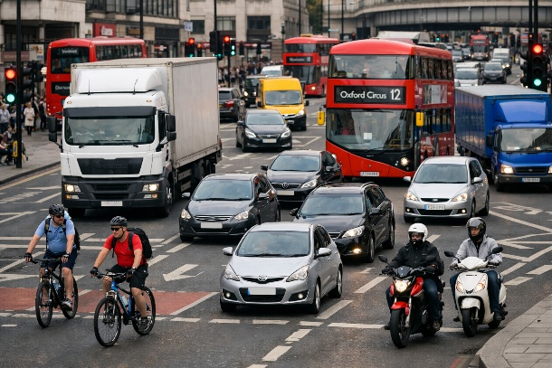  MATHS  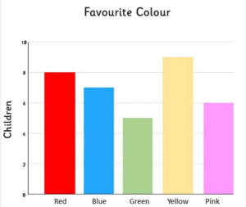  Create a bar chart like the one above for the number of cars, buses, lorries, motorcycles, and bicycles in the picture. Think carefully about the scale.  **Don’t forget to complete tasks on MyMaths and practise times tables on TTRS**
SPELLINGS
occasion occasionally often opposite
ordinary particular peculiar
perhaps popular position
**Be ready for our weekly quiz**
Remember to read for at least 20mins every day. Have a brilliant weekend!

Year 3 Home Learning 25th June 2026
**Grown-ups ~ please supervise your child’s home learning so they are attempting the work correctly**
Imagine you found a black hat like the boy in the story and in the night something magical happened…  Write and draw about it. Be as descriptive as you can. | MATHS  Create a bar chart like the one above for the number of cars, buses, lorries, motorcycles, and bicycles in the picture. Think carefully about the scale.  **Don’t forget to complete tasks on MyMaths and practise times tables on TTRS**
SPELLINGS
occasion occasionally often opposite
ordinary particular peculiar
perhaps popular position
**Be ready for our weekly quiz**
Remember to read for at least 20mins every day. Have a brilliant weekend!

