Year 5 Home Learning 18th June 2026
Culture Week –  During Culture Week, we found out about Steve Irwin (a famous Australian conservationist).  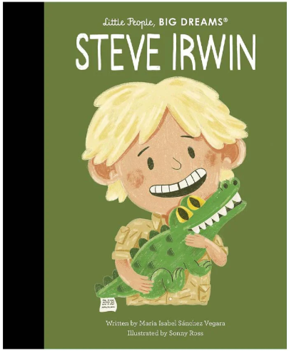  We would like you to research him or another well-known Australian and create a fact file all about them!  Choose one of the important Australians from below or find your own online! | Spellings – nouns ending with ‘y’ that become ‘ies’ in the plural form.  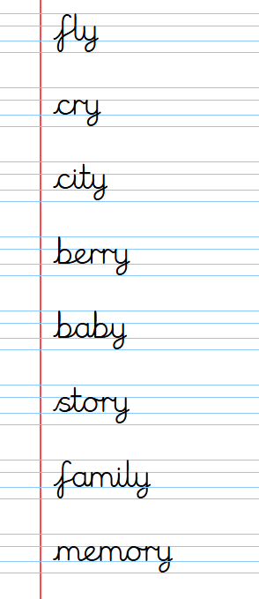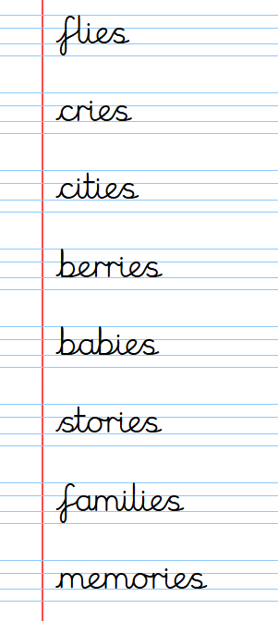  Challenge: Can you write a sentence for each of these nouns?
    Mandawuy Yunupingu  (teacher and musician) |   Steve Irwin  (conservationist) |   Evonne Goolagong Cawley  (tennis player)
    Tim Minchin  (comedian, musician, composer) | 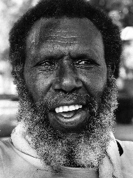  Eddie Mabo  (civil rights campaigner) |   Kylie Minogue  (singer)
Maths



Log in to your MyMaths account and try some of the activities that your teacher has set for you on decimals.



Log in to your TTRS account and practise your times tables.

Remember to read for at least 20 minutes every day!

