Year 5 Home Learning 1st July 2026
In maths, we have been talking about perimeter.  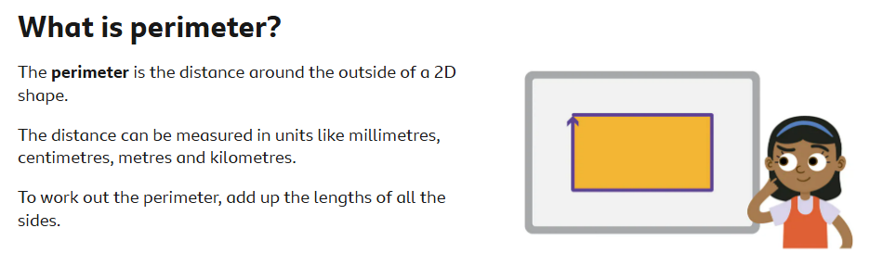  Rectangle Challenge  Can you find every possible rectangle with a perimeter of 12 cm?  This week, you are going to become a maths detective!  Your Challenge  Draw as many different rectangles as you can with a perimeter of exactly 12 cm.  The rectangles do NOT have to be drawn to scale. A quick sketch is fine, as long as you:  - label the length and width clearly  - make sure the measurements add up to a perimeter of 12 cm  - Remember to think about decimals!  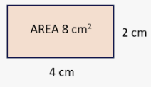 | Spellings  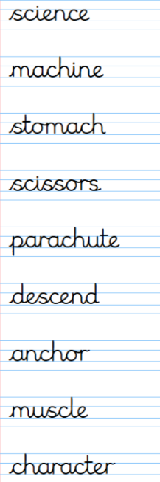  Challenge: Can you make a story which includes all these words?
Maths



Log in to your MyMaths account and try some of the activities that your teacher has set for you on percentages



Log in to your TTRS account and practise your times tables.

REMEMBER! Swimming lessons begin on Monday

