Year 6 Home Learning 10/09/26
Art | Maths
In Art, we have been studying Caravaggio's Medusa and exploring how artists use facial expressions to convey powerful emotions.  For home learning, use a mirror to carefully observe your own face and create a line drawing self-portrait. Your drawing should focus on one of the following expressions:  - anger  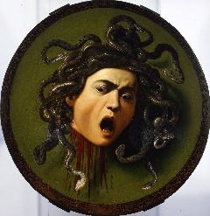  - happiness  - confusion  As you look in the mirror, pay close attention to how your facial features change. Think about the shape and position of your:  - eyes  - eyebrows  - mouth  - forehead  Avoid shading or colouring and concentrate on capturing the emotion through the lines and details of your face. | Check Maths.co.uk for  this week’s activity.    Times Tables Rockstars  Practise your times tables on Times Tables Rockstars!  
Spellings
Can you learn these spellings for our quiz next week? Practise by writing a sentence for each word.

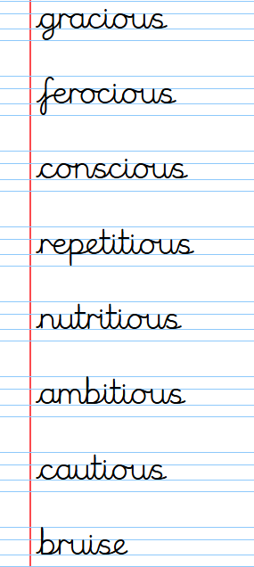
Remember to read for at least 20 minutes every day!

Year 6 Home Learning 10/09/26
Art | Maths
In Art, we have been studying Caravaggio's Medusa and exploring how artists use facial expressions to convey powerful emotions.  For home learning, use a mirror to carefully observe your own face and create a line drawing self-portrait. Your drawing should focus on one of the following expressions:  - anger  - happiness  - confusion  As you look in the mirror, pay close attention to how your facial features change. Think about the shape and position of your:  - eyes  - eyebrows  - mouth  - forehead  Avoid shading or colouring and concentrate on capturing the emotion through the lines and details of your face. | Check Maths.co.uk for  this week’s activity.  Times Tables Rockstars  Practise your times tables on Times Tables Rockstars!
Spellings
Can you learn these spellings for our quiz next week? Practise by writing a sentence for each word.

Remember to read for at least 20 minutes every day!

