Year 2 Home Learning - 17th September 2026
History  This week, we have been looking at toys from today and have been discussing different questions.  For your Home Learning, we would like you to ask your adults about toys they played with when they were children.  -What was your favourite toy? Why?  -How did it work?  -What was it made from?  You can also draw a picture of their toy and share your work with the rest of the class.  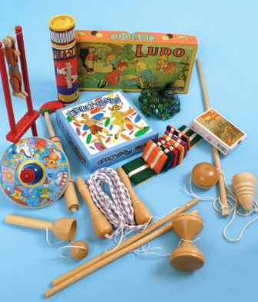 | Maths  Over the past two weeks we have been learning how to partition 2-digit numbers into tens and ones. We have also been thinking about comparing 2-digit numbers, identifying the smallest and greatest numbers. We then went on to splitting a 2-digit number into tens and ones and drawing them in a part, part whole model. Have a look at an example below.  Please have a try at the worksheet attached and let us know how you get on.
Spelling
We have taken these words from the Year 1 and 2 Common Exception word list. We would like you to practise writing these words at home so you can apply them to your writing in class.

they be he
door floor poor
Remember to read for at least 20 mins every day

