Year 6 Home Learning 24/09/26
History | Maths
In History, we have been learning about the ancient Egyptians. This week, we visited the Horniman Museum and handled ancient Egyptian artefacts (belongings).  For home learning this week, create a museum poster about three ancient Egyptian artefacts.  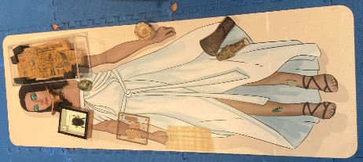  - Choose three artefacts you handled (e.g. head rest, scarab beetle, Eye of Horus, piece of sarcophagus, necklace, papyrus paper, cartouche, shabtis)  - Draw the objects.  - Annotate the images with information, including:  - Name of the artefact  - What it was made from  - What it was used for  - What it tells us about Ancient Egyptian life  If you are not sure, you could always use google to help you search the items! | Check Maths.co.uk for  this week’s activity.    Times Tables Rockstars  Practise your times tables on Times Tables Rockstars!  
Spellings
Can you learn these spellings (adding vowel suffixes to words ending in ‘fer’) for our quiz next week? Practise by writing a sentence for each word.
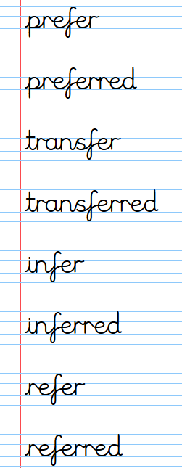
Remember to read for at least 20 minutes every day!

Year 6 Home Learning 24/09/26
History | Maths
In History, we have been learning about the ancient Egyptians. This week, we visited the Horniman Museum and handled ancient Egyptian artefacts (belongings).  For home learning this week, create a museum poster about three ancient Egyptian artefacts.  - Choose three artefacts you handled (e.g. head rest, scarab beetle, Eye of Horus, piece of sarcophagus, necklace, papyrus paper, cartouche, shabtis)  - Draw the objects.  - Annotate the images with information, including:  - Name of the artefact  - What it was made from  - What it was used for  - What it tells us about Ancient Egyptian life  If you are not sure, you could always use google to help you search the items! | Check Maths.co.uk for  this week’s activity.  Times Tables Rockstars  Practise your times tables on Times Tables Rockstars!
Spellings
Can you learn these spellings (adding vowel suffixes to words ending in ‘fer’) for our quiz next week? Practise by writing a sentence for each word.
Remember to read for at least 20 minutes every day!

