Year 3 Home Learning 25th September 2026
HISTORY  We had a great day at the Ragged School!  Look at the Victorian objects. What are they? What were they used for?  Write a sentence about each one!  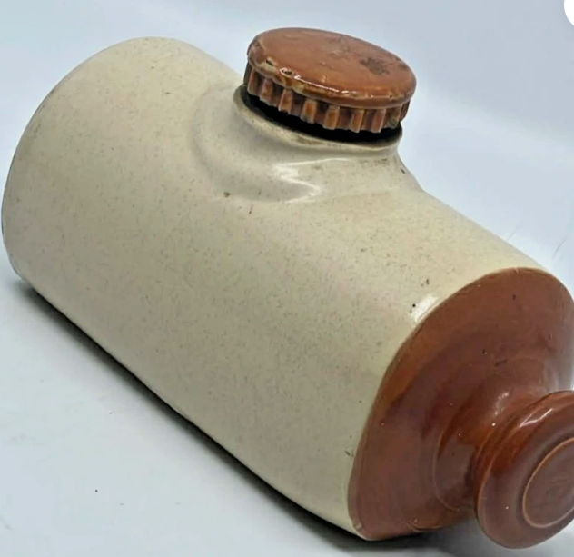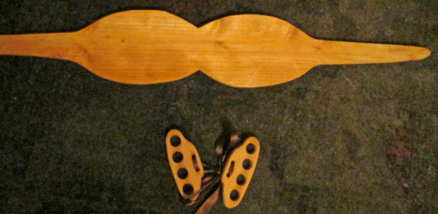  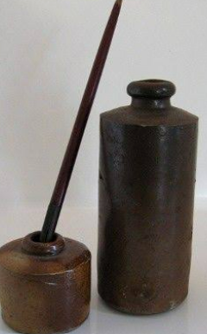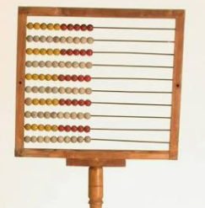 | MATHS  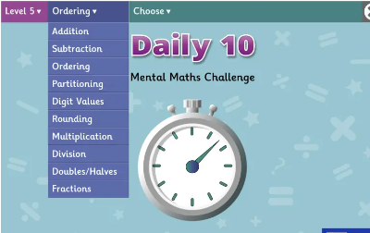  Play Daily 10!  https://www.topmarks.co.uk/maths-games/daily10  Don’t forget to log onto MyMaths and Times-Table Rockstars
SPELLING
Revise the spelling of the long
-e- vowel sound.
free squeak weak
these extreme relief
niece he even increase
*If your child has difficulty learning spellings, concentrate on the bold words*
Remember to read for at least 20mins every day.

