Year 2 Home Learning – 1st October 2026
Black History Month  This month we will be celebrating Black History Month in the UK. The theme for this year is, Honouring our communities! In class, we will be learning about many significant black figures and exploring their contributions to British history.  For your Home Learning, we would like you to choose a person from the list below to find some facts about. Talk to someone at home and tell them about the facts you learn – or you can write your facts too!  People you might like to learn about are:  Frank Bailey – the UK’s first black firefighter  Samuel Coleridge-Taylor – world famous musical composer  Maya Angelou- Poet and activist  John Kent- UK’s first black police man  Diane Abbot- First black woman elected to UK parlement | Maths  This week, we have set you a task on MyMaths. Please remember to sign on to check.  In class we have been working on number patterns. Look at the number patterns below and see if you can fill in the missing numbers.  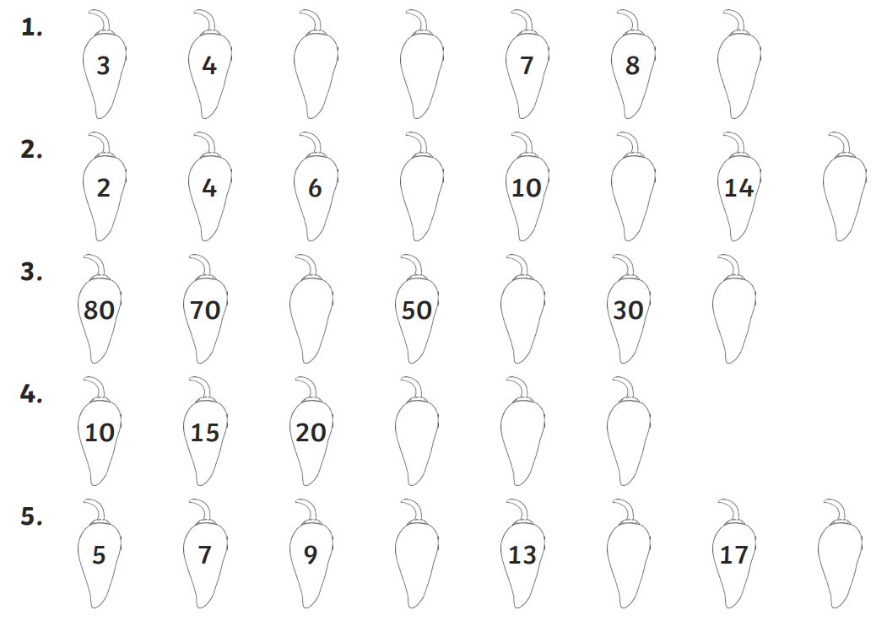
Spelling
We have taken these words from the Year 1 and 2 Common Exception word list. We would like you to practise writing these words at home so you can apply them to your writing in class.
today said me
because kind find
Remember to read for at least 20 mins every day

