Year 6 Home Learning 1.10.26
Focus on Black History Month | Maths
Black History Month takes place every October. The theme this year is  ‘Honouring Our Communities’  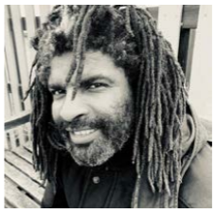  This is Thulani Shuku – an artist and art teacher from South Africa who now lives in Lewisham.  We will be using Thulani’s artwork to inspire us during Black History Month.  Fact File  Can you use the Internet to create a fact file about Thulani’s life so far?  You could include:  - A timeline of key events in his life  - Pictures of his artwork  - Interesting facts  - A quote from the artist |   Log in to discover your task for this week on multiplying.    Login in to practice your times tables
Spellings
Silent Letters
Can you learn these spellings for our quiz next week?

foreign
muscle
yacht
stomach
knuckle
solemn
island
subtle

Practise by writing a sentence for each word.
Remember to read for at least 20 minutes every day!
