Year 3 Home Learning 2nd October 2026
**Grown-ups ~ please supervise your child’s home learning so they are attempting the work correctly**
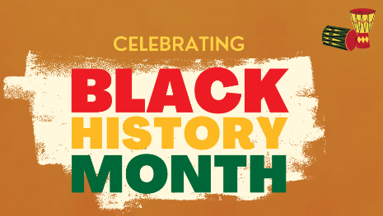  October is Black History Month!  For Black History month we are going to be creating self-portraits inspired by local artist, Thulani Shuku.  He often paints people with flowers behind them.  Create a portrait of yourself or a family member- be creative!  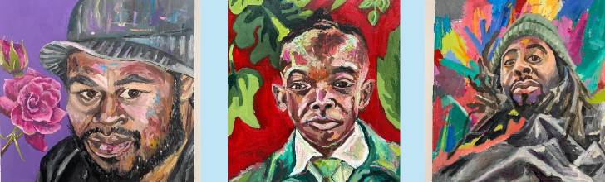 | MATHS
Practise your 2, 5 and 10 times-tables. Can you do them going forwards AND backwards? E.g. 0X2=0, 1X2=2. 3X2=6…

Challenges:
- Can you count in 10s starting from a different number? E.g. 4, 14, 24, 34…

SPELLING
Revise the spelling of the long
-i- vowel sound.
July why while
inside knife surprise
bright knight library

*If your child has difficulty learning spellings, concentrate on the bold spellings *
Remember to read for at least 20mins every day. Have a brilliant weekend!

