Year 6 Home Learning 08/10/26
English | Maths
Writing  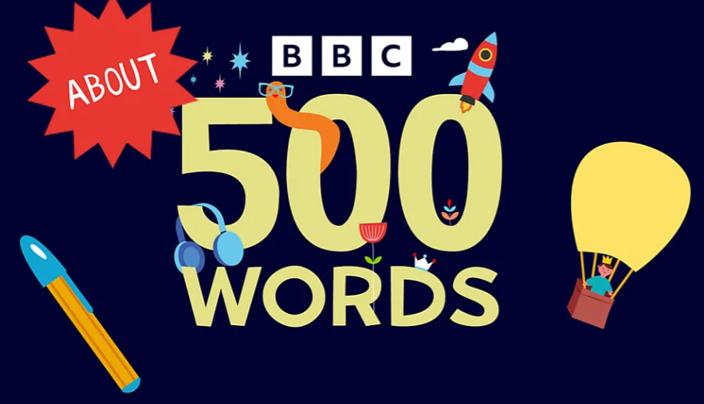  We’re taking part in the 500 Words story writing competition! This is your chance to become share your stories with the whole country!  Write an original story of no more than 500 words. It can be about anything you like. It could be funny, spooky, magical, adventurous… anything you want to write about!  How to enter the competition:  Ask an adult at home to help you submit your story online at the official 500 Words website.  Print a copy or write it out neatly and bring it into school.  We’ll be sharing our stories in class, so get ready to wow your classmates with your creativity! | Check Maths.co.uk for  this week’s activity.    Times Tables Rockstars  Practise your times tables on Times Tables Rockstars!  
Spellings
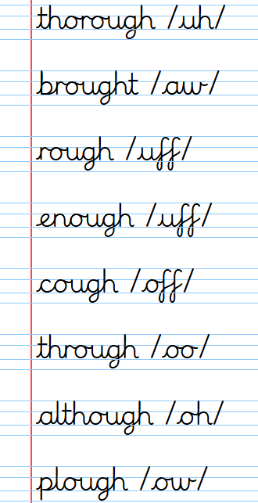
Can you learn these spellings containing the ‘ough’ letter string for our quiz next week:
Practise by writing a sentence for each word.
Remember to read for at least 20 minutes every day!
Year 6 Home Learning 08/10/26
English | Maths
Writing  We’re taking part in the 500 Words story writing competition! This is your chance to become share your stories with the whole country!  Write an original story of no more than 500 words. It can be about anything you like. It could be funny, spooky, magical, adventurous… anything you want to write about!  How to enter the competition:  Ask an adult at home to help you submit your story online at the official 500 Words website.  Print a copy or write it out neatly and bring it into school.  We’ll be sharing our stories in class, so get ready to wow your classmates with your creativity! | Check Maths.co.uk for  this week’s activity.  Times Tables Rockstars  Practise your times tables on Times Tables Rockstars!
Spellings
Can you learn these spellings containing the ‘ough’ letter string for our quiz next week:
Practise by writing a sentence for each word.
Remember to read for at least 20 minutes every day!

