Year 2 Home Learning – 5th November 2026
English  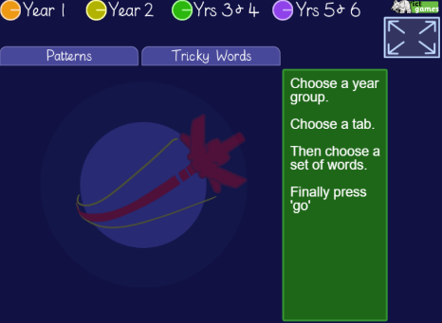  This week, we really would like you to refresh your memory on some important spellings. Use the ‘look, cover, check’ game to help you (click the link below).  https://ictgames.com/mobilePage/lcwc/index.html | Maths  This week we have started to learn more about subtraction. We have introduced solving subtraction questions using a number line, partitioning and column subtraction.  Please choose the method you would like to get the answers to the questions below.  - 46 – 5 =  - 39 – 4 =  - 27 – 3 =  - 54 – 4 =  - 66 – 5 =  - 78 – 7 =  - 89 – 8 =  - 99 – 5 =
Spelling
We have taken these words from the Year 1 and 2 Common Exception word list. We would like you to practise writing these words at home so you can apply them to your writing in class.

friend school put
children wild climb
Remember to read for at least 20 mins every day

