Year 3 Home Learning - 4th November 2026
**Grown-ups ~ please supervise your child’s home learning so they are attempting the work correctly**
Geography  Your task: Choose a city in the United Kingdom and create a fact file to teach your classmates about it.  You could choose London, Edinburgh, Cardiff, Liverpool, Manchester, Birmingham, Belfast or another UK city.  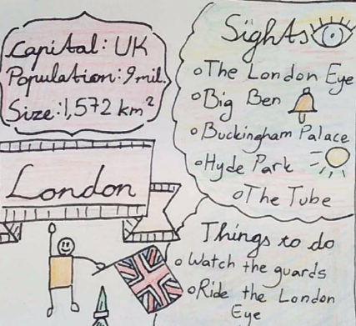  You could include: Location, famous landmarks, population, things to do, famous people, its history… | Maths  Go on TTRS, MyMaths and Topmarks to practise maths!
SPELLING

Modal verbs: practise spelling these words and copy and complete the sentences.
could, would, should, couldn’t, wouldn’t, shouldn’t

You ____ read for twenty minutes a day.
The Victorians _______ watch TV because it hadn’t been invented yet!
If I could visit any country, I _______ go to Ghana.

Challenge: Make your own sentences with these modal verbs

Remember to read for at least 20mins every day.!

