Case Study: Field Application of Retego Labs Sulfate Reducing Bacteria Test

Retego Labs SRB Test Description
The Retego Labs Sulfate Reducing Bacteria (SRB) test rapidly measures SRB populations in commercial, industrial, and oilfield waters. The test measures SRB levels in less than 24 hours compared to greater than 7 days for other commonly used methods such as serial dilution, most probable number (MPN) and quantitative polymerase chain reaction (qPCR).

The assay is based on sulphate reduction, a metabolic process unique to SRB, and targets a series of SRB-specific enzymes, including dissimilatory sulfite reductase, which produces H₂S as a by-product. A fluorescent molecule is released upon reaction with enzymes, creating a visible relationship between SRB presence and sample fluorescence under blue light excitation where it emits a greenish-yellow glow.

The method uses a two-part assay detection system (Figure 1) to reduce false positives caused by H₂S which is a common issue with the SRB serial dilution method. The first assay detects the bacterial enzyme known to be present in SRBs, while the second assay confirms the presence of H₂S. Since SRB produces H₂S, both assays must return positive results for the sample to be confirmed as SRB-positive. The time taken for the SRB assay to change color is relative to SRB populations as follows:

  - 0-1 hour ⪆ 1,000,000 cfu/mL (log 6 cfu/mL)
  - 4 hours ≈ 100,000 cfu/mL (log 5 cfu/mL)
  - 8 hours ≈ 10,000 cfu/mL (log 4 cfu/mL)
  - 24 hours ≈ 1,000 cfu/mL (log 3 cfu/mL)

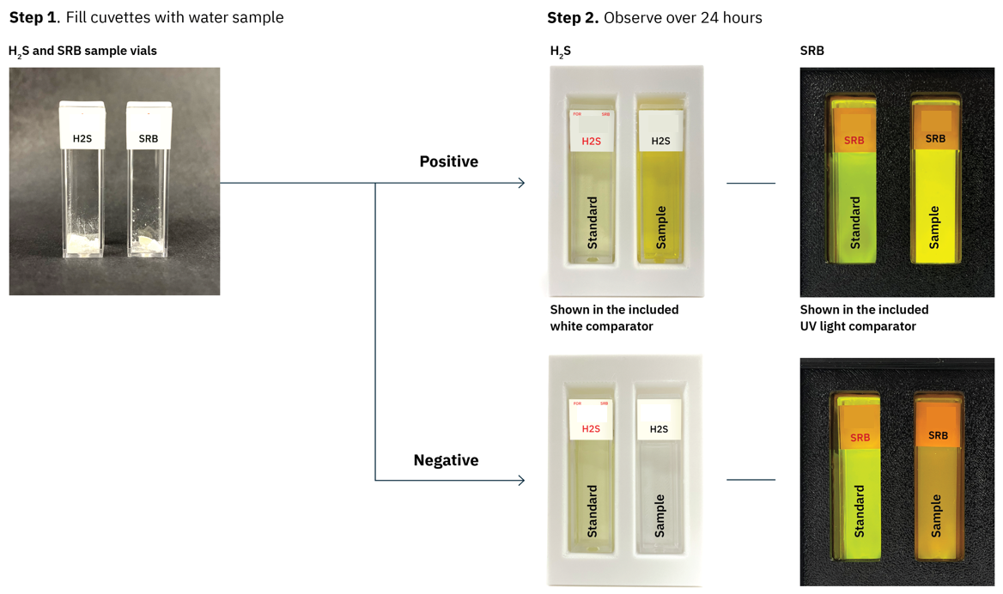
Figure 1: SRB Rest Workflow

SRB Test Product Information
To be filled out.

Retego Labs SRB Test Case Study

Field Study Background
Numerous wells in an onshore oilfield in Egypt were suffering from high bacteria levels and suspected microbially induced corrosion issues. To gain a deeper understanding of the problem, the operator sought field-ready bacterial testing methods that could be used to measure bacteria populations alongside traditional techniques. Consequently, the operator initiated a bacteria survey using the Retego Labs SRB test, SRB serial dilution test (SDT) and hydrolase assay to measure total bacteria.

Field Application
Before field use, the Retego SRB detection assay was validated using the standard SRB SDT and a total bacteria detection test (hydrolase assay) to confirm its capability. The Retego SRB test identified SRB presence before the SDT bottles exhibited color changes or detectable sulfide production. The study demonstrated that the Retego SRB test was able to detect SRB as low as 3 log CFU/ml and up to 6 log CFU/ml (or greater) which was in agreement with the serial dilution results. Results from the hydrolase assay bacteria test further confirmed high microbial concentrations, showing 5–6 log bacterial presence in the sample, agreeing with the findings from the Retego SRB test.

For the field study, produced water samples were collected from 9 mature conventional oil wells. The wells were a mixture of wells that had previously tested positive or negative for SRB. The water samples were analyzed for SRB using the Retego Labs assay and SDT, and tested for total bacteria using the hydrolase assay.

Bacteria Field Results
The Retego SRB results agreed closely to the hydrolase method and the SRB SDT (Table 1) and the findings supported the Retego SRB test’s ability to detect the presence of SRB. When SRB were detected in the water samples by the Retego Labs SRB test, the results from the hydrolase assay and SDT were within 1 -2 log of the Retego SRB result. Furthermore, when SRB were detected the Retego test also gave a positive result for H₂S confirming the presence of SRB. Finally, when SRB were not detected, the corresponding H₂S result was also negative.

Well | Hydrolase  Assay  (cfu/ml) | SRB SDT.  Bottle Turns  (log CFU/ml) | Retego SRB.  Hours to  Color Change | Retego SRB  (cfu/mL) | Retego  H₂S Result
A | 10 | 0 | >24 | 0 | Negative
B | 0 | 0 | >24 | 0 | Negative
C | 0 | 0 | >24 | 0 | Negative
D | ≈4,000 | 3 (log 3) | 8 | ≈10,000 | Positive
E | ≈20,000 | 4 (log 4) | 4 | ≈100,000 | Positive
F | ≈400 | 1 (log 1) | 24 | ≈1,000 | Positive
G | ≈8,300 | 3 (log 3) | 12 | ≈1,000-10,000 | Positive
H | 0 | 0 | >24 | 0 | Negative
I | 0 | 0 | >24 | 0 | Negative
J | ≈70,000 | 4 (log 4) | 1 | ≈1,000,000 | Positive
Table 1: Results of Field Validation Study

