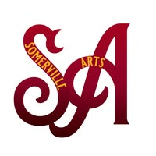
Somerville Arts
A NJ Non Profit Corporation

Holiday Art Market 2025
Artist Application

NAME:

EMAIL:

PHONE:

ADDRESS:

ART MEDIA:

WEBSITE/SOCIAL MEDIA:

Please email this form and 2 photos we can use for advertising to: susanantin@verizon.net

Thank you for supporting Somerville Arts!
Somerville Arts is a charitable organization within the meaning of Section 501c3 dedicated to building community through the arts and arts education. Promoting the advancement, development and support of the visual, musical, physical and literary arts and historical cultural events with the belief this will positively contribute to the quality of life for all residents and contribute to economic and community development in the Borough of Somerville, New Jersey and its surrounding area.
Somerville Arts, formerly Arts on Division, P.O. Box 220, Somerville, NJ 08876 email: artsondivision1@gmail.com Website: www.artsondivision.com

