Dishes and their allergen content: Meat Free 2
Dishes | 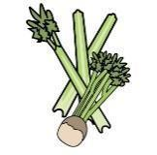 | 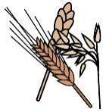 | 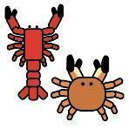 |  |  | 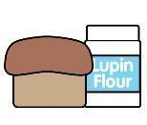 | 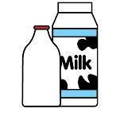 |  | 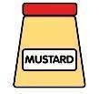 |  |  | 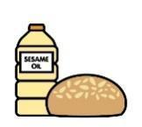 |  | 
V = Vegetarian  VG = Vegan  VGA = Vegan Available | Celery | Cereals containing gluten* | Crustaceans | Eggs | Fish | Lupin | Milk | Mollusc | Mustard | Nuts† | Peanuts | Sesame seeds | Soya | Sulphur Dioxide
Vegetable Fingers  VVG  Sweet Potato Falafel  VVG |  | Y  wheat
Vegetable Korma  V |  |  |  |  |  |  | Y
Vegetable/
Chickpea/
Bean Balti
VVG
Pesto Pasta  V |  |  |  |  |  |  | Y
Tomato Soup  VVGA  Vegetable Soup VVG | Y | Y  wheat  Barley |  |  |  |  | Y
Vegetable Soup  VVG | Y | Y  wheat  Barley
Vegetable Nuggets V
Vegetable Crisp Bake V
 | Reviewed by: S Masters  Review Date: July 2026

