Dishes and their allergen content: Meat Free 1
Dishes | 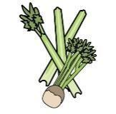 |  |  |  |  | 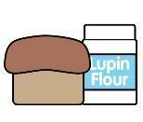 | 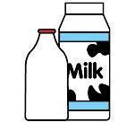 |  | 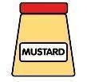 |  |  | 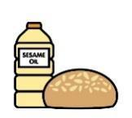 |  | 
V = Vegetarian  VG = Vegan  VGA = Vegan Available | Celery | Cereals containing gluten* | Crustaceans | Eggs | Fish | Lupin | Milk | Mollusc | Mustard | Nuts† | Peanuts | Sesame seeds | Soya | Sulphur Dioxide
Macaroni Cheese  Cauliflower/ Broccoli Cheese  VVGA |  | Y  wheat |  |  |  |  | Y
Tomato Pasta  Vegetable Lasagne  Bolognaise  VVGA |  | Y  wheat
Mushroom Pasta Bake  VVGA |  | Y  wheat |  |  |  |  | Y
Cheese and Tomato Pizza  Mixed Pepper Pizza  VVGA |  | Y  wheat |  |  |  |  | Y
Mozzarella Sticks V |  | Y  wheat |  |  |  |  | Y
Ratatouille
VVG
Vegan Sausage Roll  VVG |  | Y  wheat  barley |  |  |  |  |  |  |  |  |  |  | Y
Crispy Breaded Mushrooms  V |  | Y  Wheat
 | Reviewed by: S Masters  Review Date: July 2026

