Dishes and their allergen content: Dessert 2
Dishes | 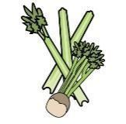 |  | 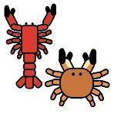 | 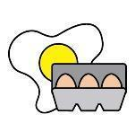 |  | 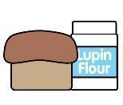 | 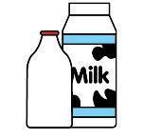 |  | 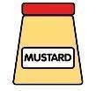 |  |  | 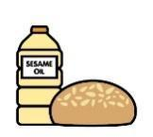 |  | 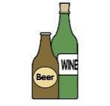
V = Vegetarian  VG = Vegan  VGA = Vegan Available | Celery | Cereals containing gluten* | Crustaceans | Eggs | Fish | Lupin | Milk | Mollusc | Mustard | Nuts† | Peanuts | Sesame seeds | Soya | Sulphur Dioxide
Sprinkle Cake  Lemon Drizzle Cake  Cup Cakes  V |  | Y  wheat |  | Y |  |  | Y
Homemade Shortbread  VVG |  | Y  wheat
Angel Delight  Raspberry  Toffee  Chocolate  V |  |  |  |  |  |  | Y
Traffic Light Jelly
Plain Jelly
Fruit Jelly
Coconut Jam Sponge  V  Chocolate Sponge  V |  | Y  wheat  Y  wheat |  | Y  Y
Jam Doughnut  Sugar Ring Doughnut  V |  | Y  wheat  Y  wheat |  | Y  Y |  |  | Y  Y |  |  |  |  | may contain  may contain | Y  Y
Chocolate Chip Cookie  V |  | Y  wheat |  | Y |  |  | Y |  |  |  |  |  | Y
 | Reviewed by: S Masters  Review Date: July 2026

