Dishes and their allergen content: Dessert 1
Dishes | 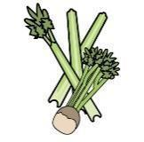 |  | 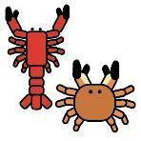 |  |  | 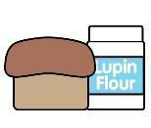 | 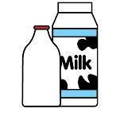 |  | 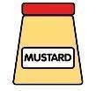 |  |  | 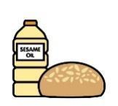 |  | 
V = Vegetarian  VG = Vegan  VGA = Vegan Available | Celery | Cereals containing gluten* | Crustaceans | Eggs | Fish | Lupin | Milk | Mollusc | Mustard | Nuts† | Peanuts | Sesame seeds | Soya | Sulphur Dioxide
Fruit Crumble  VVG |  | Y  wheat
Flapjack
VVG
Blueberry Muffin  V |  | Y  wheat |  | Y |  |  | Y |  |  | May Contain |  |  | Y
Choc Chip muffin V |  | Y  wheat |  | Y |  |  | Y |  |  | May Contain |  |  | Y
Chocolate Muffin V |  | Y  wheat |  | Y |  |  | Y |  |  | May Contain |  |  | Y
Chocolate Crispie Cake
V
Fruit Jelly
V
Fruit Salad
VVG
Custard  VVGA  Chocolate Sauce  VVGA |  |  |  |  |  |  | Y  Y
 | Reviewed by: S Masters  Review Date: July 2026

