Dishes and their allergen content: Bread
Dishes | 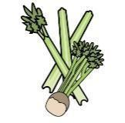 |  |  |  |  | 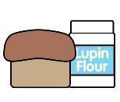 | 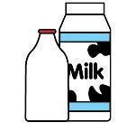 |  | 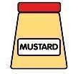 |  |  | 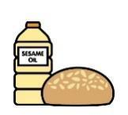 |  | 
V = Vegetarian  VG = Vegan  VGA = Vegan Available | Celery | Cereals containing gluten* | Crustaceans | Eggs | Fish | Lupin | Milk | Mollusc | Mustard | Nuts† | Peanuts | Sesame seeds | Soya | Sulphur Dioxide
Wholemeal Bread  VVG |  | Y  Wheat |  |  |  |  |  |  |  |  |  |  | Y
Crusty Bread  VVG |  | Y  wheat |  |  |  |  |  |  |  |  |  | May Contain | Y
Baguette White  VVG |  | Y  wheat |  |  |  |  |  |  |  |  |  | May Contain | Y
Naan  V  Pitta Bread  V |  | Y  wheat
Tortilla Wrap  VVG |  | Y  wheat
Garlic Bread  V |  | Y  Wheat |  |  |  |  | Y |  |  |  |  |  | Y
Burger Bun  V |  | Y  Wheat |  |  |  |  |  |  |  |  |  | May Contain
Hot Dog Roll  V |  | Y  Wheat |  |  |  |  |  |  |  |  |  | May Contain
 | Reviewed by: S Masters  Review Date: July 2026

