Dishes and their allergen content: Sauces Spreads and Sides
Dishes | 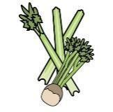 |  | 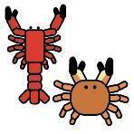 |  |  | 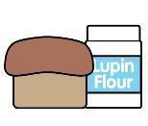 | 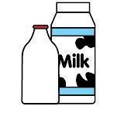 |  | 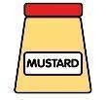 |  |  | 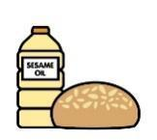 |  | 
V = Vegetarian  VG = Vegan  VGA = Vegan Available | Celery | Cereals containing gluten* | Crustaceans | Eggs | Fish | Lupin | Milk | Mollusc | Mustard | Nuts† | Peanuts | Sesame seeds | Soya | Sulphur Dioxide
Mayonnaise Sachet  V |  |  |  | Y |  |  |  |  | Y
Mayonnaise Jar  V |  |  |  | Y
Tomato Ketchup
VVG
Butter V |  |  |  |  |  |  | Y
Sunflower Spread
VVG
Gravy VVG
Yorkshire Pudding  V |  | Y  wheat |  | Y |  |  | Y
Sage & Onion Stuffing  VVG |  | Y  wheat
Brown Sauce  VVG  Vinegar  VVG |  | Y  barley  Y  barley
 | Reviewed by: S Masters  Review Date: July 2026

