Dishes and their allergen content: Vegetables 2
Dishes | 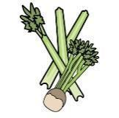 | 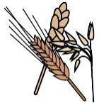 | 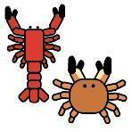 | 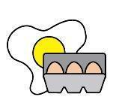 |  | 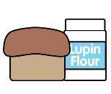 | 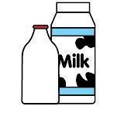 |  | 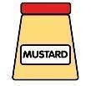 |  |  | 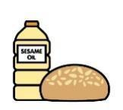 |  | 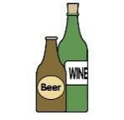
V = Vegetarian  VG = Vegan  VGA = Vegan Available | Celery | Cereals containing gluten* | Crustaceans | Eggs | Fish | Lupin | Milk | Mollusc | Mustard | Nuts† | Peanuts | Sesame seeds | Soya | Sulphur Dioxide
Stir Fry Vegetables
VVG
Baked Beans
VVG
Reduced Sugar Baked Beans
VVG
Salad
VVG
Mixed Salad
VVG
Cucumber Salad
VVG
Salad Garnish
VVG
Coleslaw
VVGA
 | Reviewed by: S Masters  Review Date: July 2026

