Dishes and their allergen content: Vegetables 1
Dishes | 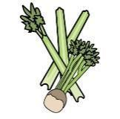 | 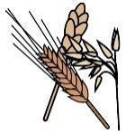 | 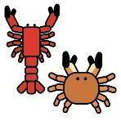 | 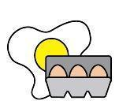 |  | 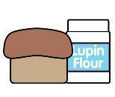 | 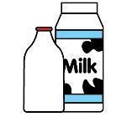 |  | 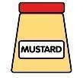 |  |  | 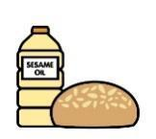 |  | 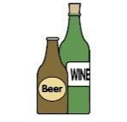
V = Vegetarian  VG = Vegan  VGA = Vegan Available | Celery | Cereals containing gluten* | Crustaceans | Eggs | Fish | Lupin | Milk | Mollusc | Mustard | Nuts† | Peanuts | Sesame seeds | Soya | Sulphur Dioxide
Carrots
VVG
Swede
VVG
Green Beans Cut
VVG
Green Beans Sliced
VVG
Green Beans Whole
VVG
Broccoli VVG
Cauliflower
VVG
Peas VVG
Sweetcorn & on the Cob
VVG
Mixed Vegetables
VVG
 | Reviewed by: S Masters  Review Date: July 2026

