Dishes and their allergen content: Potatoes
Dishes | 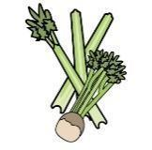 | 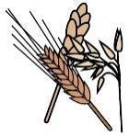 | 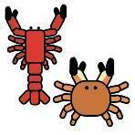 | 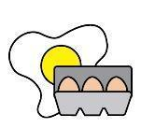 | 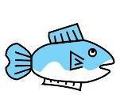 | 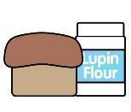 | 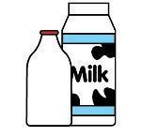 | 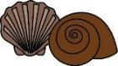 | 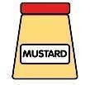 | 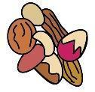 | 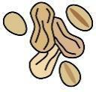 | 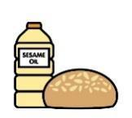 | 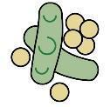 | 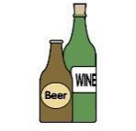
V = Vegetarian  VG = Vegan  VGA = Vegan Available | Celery | Cereals containing gluten* | Crustaceans | Eggs | Fish | Lupin | Milk | Mollusc | Mustard | Nuts† | Peanuts | Sesame seeds | Soya | Sulphur Dioxide
New Potatoes
VVG
Roast Potatoes
VVG
Mashed Potato  VVGA |  |  |  |  |  |  | Y
Chips
VVG
Wedges Plain
VVG
Wedges Seasoned
VVG
Cubes Plain
VVG
Cubes Seasoned
VVG
Jacket Potato
VVG
 | Reviewed by: S Masters  Review Date: July 2026

